Quintessence:

1. What is locomotion? [1 folie]
--> definition, complement to manipulation

Locomotion is the complement of manipulation. In manipulation, the robot arm is fixed but
moves objects in the workspace by imparting force to them. In locomotion, the environ-
ment is fixed and the robot moves by imparting force to the environment. In both cases, the
scientific basis is the study of actuators that generate interaction forces, and mechanisms
that implement desired kinematic and dynamic properties. [Introduction to Autonomous Mobile Robots [book]]

Actuation, the focus of this lecture, is the ability of the robot to move and to manipulate the world. Specifically, we differentiate between locomotion as the ability of the robot to move and manipulation as the ability to move objects in the environment of the robot. Both activities are closely related: during locomotion the robot uses its motors to exert forces on its environment (ground, water or air) to move itself, during manipulation it uses – sometimes the same – motors to exert forces on objects to move them relative to the environment.

Locomotion includes very different concepts of motion including rolling, walking, running, jumping, sliding (undulatory locomotion), crawling, climbing, swimming, and flying. Although walking, running, jumping, crawling and climbing seem to be very similar concepts at first sights, they are drastically different in terms of energy consumption, kinematics, stability, and capabilities required by the robot that implements them. Examples include:

Walking: Honda’s ASIMO (2-legged) and Sony’s AIBO.
Running: University of Michigan’s MABEL robot (2-legged) and Boston Dynamics’ Big Dog (4-legged).
Jumping: EPFL’s Micro-gliders
Sliding: EPFL’s Salamandra robot
Crawling: Harvard’s mesh worm
Climbing: Stanford’s StickyBot
Swimming: FESTO’s AquaJelly, MIT’s AMOUR robot, and various robotic fish.

[http://correll.cs.colorado.edu/?p=869]

2. Why do we need robots which can do locomotion? Where do we need them? [1 folie]

- robot needs locomotion to move through environment
- increasing number of robots for environments which are not built for them
- one goal is extended use in daily life (home, medical treatment, nursing, entertainment)
- actual usage e.g. cleaning robots, pet robots
- extreme environments (after disasters, dangerous working places, war zones)
- human like robots, including human locomotion, seem to suit the best in a world shaped by humans

3. important issues of locomotion concepts [2 folien]
- Stability
• Number and geometry of contact points
• Center of gravity
• Static/dynamic stability
• Inclination of terrain

– Characteristics of contact
• Contact point or contact area
• Angle of contact
• Friction

– Type of environment
• Structure
• Medium (water, air, soft or hard ground)

(- Velocity)
• safety
• accuracy

(- energy efficiency)

(- degree of freedom )

4. walking vs. rolling
Owing to these limitations, mobile robots generally locomote either using wheeled
mechanisms, a well-known human technology for vehicles, or using a small number of
articulated legs, the simplest of the biological approaches to locomotion (see figure 2.2).
In general, legged locomotion requires higher degrees of freedom and therefore greater
mechanical complexity than wheeled locomotion. Wheels, in addition to being simple, are
extremely well suited to flat ground. As figure 2.3 depicts, on flat surfaces wheeled loco-
motion is one to two orders of magnitude more efficient than legged locomotion. The rail-
way is ideally engineered for wheeled locomotion because rolling friction is minimized on
a hard and flat steel surface. But as the surface becomes soft, wheeled locomotion accumu-
lates inefficiencies due to rolling friction whereas legged locomotion suffers much less
because it consists only of point contacts with the ground. This is demonstrated in figure
2.3 by the dramatic loss of efficiency in the case of a tire on soft ground.
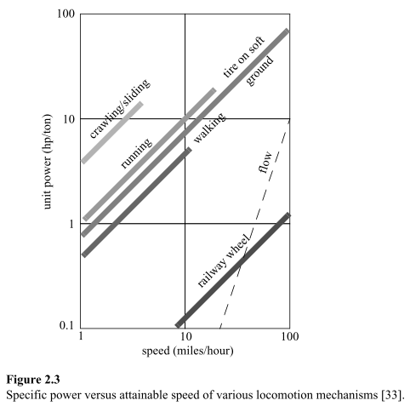
In effect, the efficiency of wheeled locomotion depends greatly on environmental qual-
ities, particularly the flatness and hardness of the ground, while the efficiency of legged
locomotion depends on the leg mass and body mass, both of which the robot must support
at various points in a legged gait.
It is understandable therefore that nature favors legged locomotion, since locomotion
systems in nature must operate on rough and unstructured terrain. For example, in the case
of insects in a forest the vertical variation in ground height is often an order of magnitude
greater than the total height of the insect. By the same token, the human environment fre-
quently consists of engineered, smooth surfaces, both indoors and outdoors. Therefore, it
is also understandable that virtually all industrial applications of mobile robotics utilize
some form of wheeled locomotion.

[Introduction to Autonomous Mobile Robots [book]]

Legged Mobile Robots
Legged locomotion is characterized by a series of point contacts between the robot and the
ground. The key advantages include adaptability and maneuverability in rough terrain.
Because only a set of point contacts is required, the quality of the ground between those
points does not matter so long as the robot can maintain adequate ground clearance. In addi-
tion, a walking robot is capable of crossing a hole or chasm so long as its reach exceeds the
width of the hole. A final advantage of legged locomotion is the potential to manipulate
objects in the environment with great skill. An excellent insect example, the dung beetle, is
capable of rolling a ball while locomoting by way of its dexterous front legs.
The main disadvantages of legged locomotion include power and mechanical complex-
ity. The leg, which may include several degrees of freedom, must be capable of sustaining
part of the robot’s total weight, and in many robots must be capable of lifting and lowering
the robot. Additionally, high maneuverability will only be achieved if the legs have a suf-
ficient number of degrees of freedom to impart forces in a number of different directions.
[Introduction to Autonomous Mobile Robots [book]]

Leg configuration
To move a leg forward at least two degrees of freedom are required, one for lifting and one for swinging. Most legs have three degrees of freedom; this makes the robot able to travel in rougher terrain and to do more complex manoeuvres. Figure 5 shows the leg of the Titan VIII robot from the Tokyo Institute of Technology. This leg has three degrees of freedom. In general, adding degrees of freedom to a robots leg means increasing the manoeuvrability of the robot, the range of terrain on which it can travel and the ability to travel in a variety of gaits. But adding degrees of freedom causes also some disadvantages, because for moving additional joints and more servos are required, this increases the power consumption and the weight of the robot. Furthermore controlling the robot becomes more complex, because more motors have to be controlled and actuated at the same time.
If the robot has more than one leg there is the issue of leg coordination for locomotion. The total number of possible gaits in which a robot can travel depends on the number on legs it has. The gait is a periodic sequence of lift and release events for each leg. If a robot has k legs the number of possible events N is, accordant to [1],

N=(2k-1)!

In case of a bipedal walking machine (k=2) the number of possible events is
N=(2k-1)! = (2*2-1)! = 3! = 6

So there are six possible different events, these are
1. Lift left leg
2. Release left leg
3. Lift right leg
4. Release right leg
5. Lift both legs together
6. Release both legs together

In case of k=6 legs there are already 39916800 possible events, in face of that, controlling a six legged robot is because of the large number of possible events more complex than controlling a two legged robot. But robots with fewer legs have some other problems; one of the most complex problems is stability as mentioned before. In the following different leg configurations, advantages/disadvantages of these and examples of robots are shown.
[Principles of robot locomotion [paper]]

Wheeled Mobile Robots
The wheel has been by far the most popular locomotion mechanism in mobile robotics and
in man-made vehicles in general. It can achieve very good efficiencies, as demonstrated in
figure 2.3, and does so with a relatively simple mechanical implementation.
In addition, balance is not usually a research problem in wheeled robot designs, because
wheeled robots are almost always designed so that all wheels are in ground contact at all
times. Thus, three wheels are sufficient to guarantee stable balance, although, as we shall
see below, two-wheeled robots can also be stable. When more than three wheels are used,
a suspension system is required to allow all wheels to maintain ground contact when the
robot encounters uneven terrain.
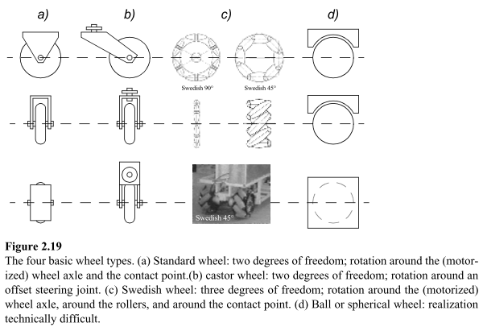
Instead of worrying about balance, wheeled robot research tends to focus on the prob-
lems of traction and stability, maneuverability, and control: can the robot wheels provide
sufficient traction and stability for the robot to cover all of the desired terrain, and does the
robot’s wheeled configuration enable sufficient control over the velocity of the robot?
[Introduction to Autonomous Mobile Robots [book]]

Mobile Robots with Wheels
● Wheels are the most appropriate solution for many applications
● Three wheels are sufficient to guarantee stability
● With more than three wheels a flexible suspension is required
● Selection of wheels depends on the application
[Autonomous Mobile Robots, Chapter 2 - Robot Locomotion [slides 2011]]

Trade-Offs
● Stability
→A statically-stable robot is one whose center of gravity lies inside the
support pattern
● Maneuverability
→How many degrees of freedom a robot can manipulate
● Controllability
→ Inversely correlated to maneuverability; how “easy” the robot is to
control to achieve the desired motion
[Autonomous Mobile Robots, Chapter 2 - Robot Locomotion [slides 2011]]

Characteristics of Wheeled Robots and Vehicles
● Stability of a vehicle is guaranteed with 3 wheels
→ center of gravity is within the triangle formed by the ground contact
point of the wheels.
● Stability is improved by 4 or more wheels
→ however, these arrangements are hyperstatic and require a flexible
suspension system.
● Bigger wheels allow overcoming higher obstacles
→ but they require higher torque or reductions in the gear box.
[Autonomous Mobile Robots, Chapter 2 - Robot Locomotion [slides 2011]]

Less than half the Earth's landmass is accessible to wheeled
and tracked vehicles, yet people and animals can go almost
anywhere on Earth. This situation motivates the development
of robot vehicles that use legs for their locomotion, thereby
embracing nature’s mobility solution. The goal is to achieve
animal-like mobility on rough and rugged terrain, terrain too
difficult for any existing vehicle.
[BigDog, the Rough-Terrain Quaduped Robot[paper]]

--> go through important issues parallel

Stability:
Surprisingly, the minimum number of wheels required for static stability is two. As shown
above, a two-wheel differential-drive robot can achieve static stability if the center of mass
is below the wheel axle. Cye is a commercial mobile robot that uses this wheel configura-
tion (figure 2.21).
However, under ordinary circumstances such a solution requires wheel diameters that
are impractically large. Dynamics can also cause a two-wheeled robot to strike the floor
with a third point of contact, for instance, with sufficiently high motor torques from stand-
still. Conventionally, static stability requires a minimum of three wheels, with the addi-
tional caveat that the center of gravity must be contained within the triangle formed by the
ground contact points of the wheels. Stability can be further improved by adding more
wheels, although once the number of contact points exceeds three, the hyperstatic nature of
the geometry will require some form of flexible suspension on uneven terrain.
[Introduction to Autonomous Mobile Robots [book]]

In general, legged locomotion requires higher degrees of freedom and therefore greater
mechanical complexity than wheeled locomotion. Wheels in addition to being simple, are extremely well suited to flat ground.
On flat hard surfaces wheeled locomotion is one or two orders or magnitude more efficient than legged locomotion.
The efficiency of wheeled locomotion depends greatly on environmental qualities, particularly the flatness and hardness of the ground. The efficiency of legged locomotion depends on the leg mass and body mass, both of which the robot must support at various points in a legged gait.
[Robotic Locomotion Concepts [slides]]

Advantages of legged locomotion:
– Adaptability & manoeuvrability over rough terrain
– Quality of ground between point contacts does not matter
– Capable of crossing chasms
– Potential to manipulate objects

Disadvantages of legged locomotion:
– Power and mechanical complexity requirements

The fewer legs the more complicated becomes locomotion
– Stability - at least three legs are required for static stability
During walking some legs are lifted
– Thus loosing stability?
For static walking at least 6 legs are required

Bipedal robots can only be statically stable within some limits, and so bipedal robots must perform continuous balance-correcting servoing even when standing still. Furthermore, each leg must have sufficient capacity to support the full weight of the robot.

The number of degrees of freedom (DOF) of a leg is determined by the number of joints it has
A minimum of two DOF is required to move a leg forward
– A lift and a swing motion
Three DOF for each leg in most cases

Adding degrees of freedom to a robot leg increases the maneuverability of the robot, both augmenting the range of terrains on which it can travel and the ability of the robot to travel with a variety of gaits. The primary disadvantage of additional joints and actuators are, energy, control and mass. Additional actuators require energey and control, and they
also add to leg mass, further increasing power and load requirements on existing actuators.
[Robotic Locomotion Concepts [slides]]

5. summery: table for walking vs rolling

(6. examples for other locomotion concepts)

